ST10258616-KYLE DRE CHETTY-WEDE5020-POE-PART 1



CONTENTS

|  |  |
| --- | --- |
| TOPIC | PAGE NUMBER |
| WEBSITE CHOICE | 1 |
|  |  |
| WEBSITE ASSETS | 2 |
|  |  |
| WEBSITE CONTENTS AND PAGES | 3 |
|  |  |
| LIST OF REFERENCES | 4 |

**WEBSITE CHOICE**

**CLEAN AIR FUND**

The clean air fund initiative is a philanthropic organization that funds and partners with other organizations that funds and partners with other organizations globally to promote air quality. This organization also builds upon public demand for clean air and support those who support the initiative to decrease air pollution. Their main goals for decreasing air pollution is giving out grants, developing projects and gathering data of the air quality. They give grants to campaigns on air pollution as well as research organizations and charities to help fund other parties who are joining the movement to better air quality. The data the organization captures for air quality is to tackle emissions, they work with partners or companies that capture data that is reliable and accessible. The reason they are pushing the movement for clean air is because air pollution is now the world’s largest environmental threat and is responsible for the seven million people that die every year due to the air that is harmful and dirty making it a major health threat. The harmful gasses in the air due to heavy industrial buildings and the emissions left by cars has caused air pollution to be bigger than diseases such as HIV, malaria and tuberculosis. This is because air particles are everywhere and invisible particles that can penetrate your organs and cells and cause major problems for your health. With the support of the people the clean air fund initiative can reduce air pollution in places that need these emissions to go down and save lives, they can improve millions of lives and strengthen societies and help the climate to reduce global warming. You can help by funding small donations to help save lives by cleaning the air better air quality leads to a better future and that is why I NGO.

**WEBSITE ASSETS**

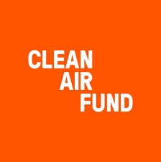

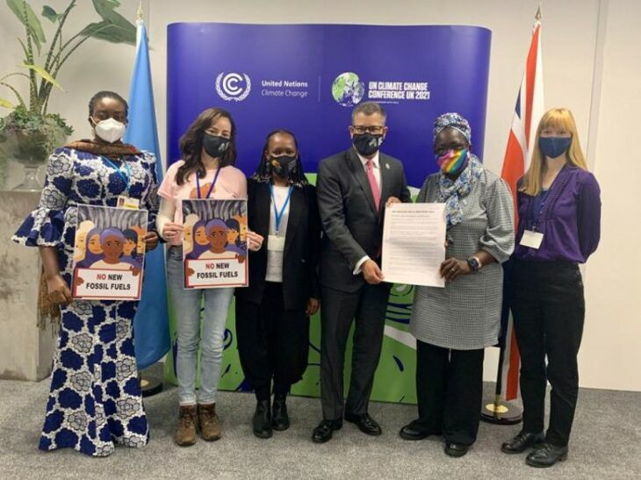

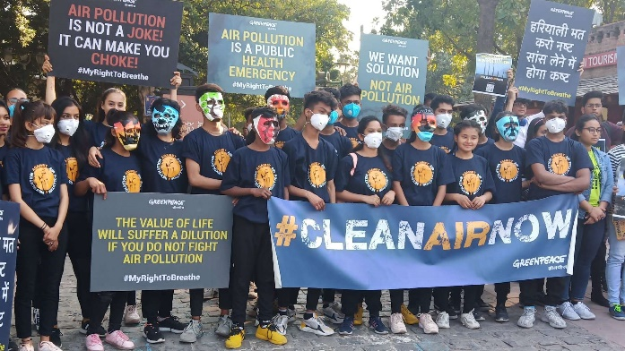

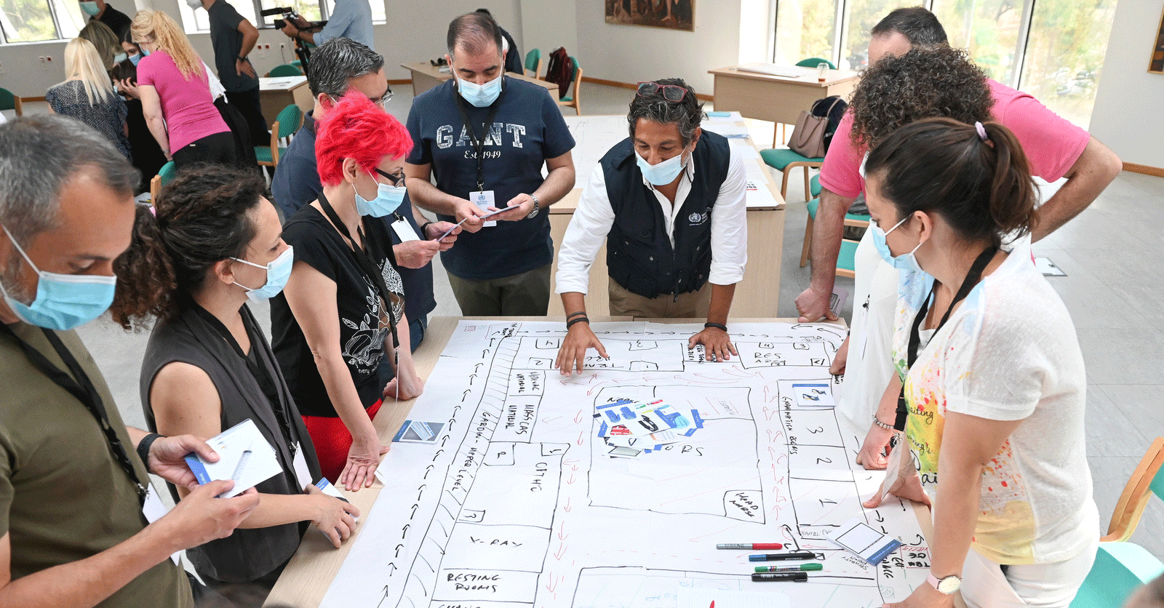

**WEBSITE CONTENT AND PAGES**

HOMEPAGE:

* Logo
* Links to other pages
* Full-width photo(Two children looking at a factory polluting the air)
* Summary of main activities
* Basic contact information
* Copyright/year

ABOUT PAGE:

* Logo
* Links to other pages
* Summary of why we clean air
* Basic contact information
* Copyright/year

SERVICE:

* Logo
* Links to other pages
* Information on services
* Basic contact information
* Copyright/year

GALLERY:

* Logo
* Links to other pages
* Pictures of campaigns
* Basic contact information
* Copyright/year

CONTACT PAGE:

* Logo
* Links to other pages
* Contact information
* Copyright/year

**LIST OF REFERENCES**

Greenpeace. 2020. Flash-mob to create awareness about air pollution. [Online]. Available at: <https://www.greenpeace.org/india/en/story/4695/flash-mob-to-create-awareness-about-air-pollution/> [Accessed 02 April 2023]

WHO. 2021. WHO and UN partners’ compendium of 500 actions aims to reduce diseases from environmental factors and save lives. [Online]. Available at: <https://www.who.int/news/item/03-09-2021-who-and-un-partners-compendium-of-500-actions-aims-to-reduce-diseases-from-environmental-factors-and-save-lives> [Accessed at 02 April 2023]

Clean Air fund. 2021. 7 clean air moments at COP26. [Online]. Available at: <https://www.cleanairfund.org/> [Accessed at 02 April 2023]

Elma. 2018. Clean Air Fund. [Online]. Available at: <https://www.elmaphilanthropies.org/elma/investments/clean-air-fund> [Accessed at 02 April 2023]

National Institute Of Environmental Health sciences. 2023. [Online]. Available at: <https://www.niehs.nih.gov/health/topics/agents/air-pollution/index.cfm> [Accessed at 02 April 2023]

**PART 2**

**IMPROVEMENTS**

* Added background color.
* Added footer block.
* Changed heading.
* Designed a table in contact.
* Made a nav bar.
* Made a button.
* All changes are coded in every .